Virtual Advocacy Day Toolkit For Community Schools

April 29, 2015

Sample Tweets

Choose the one that resonates most with you and your community. Please tweet at legislators by using their Twitter handle listed at the end of this toolkit. Also, use #communityschools, #TeenREACH, #twill, #saveafterschool, and #afterschool in your posts.

Sample Tweet 1  @InsertRepHandle, keep kids safe and engaged in #afterschool programs. #Communityschools can't afford cuts. #twill  #saveafterschool | Sample Tweet 2  @GovRauner’s $26 million cut will save #IL millions. But constituents are paying the price.@InsertRepHandle, save #communityschools #twill
Sample Tweet 3  I condemn @GovRauner’s reckless grant terminations that close doors to children & families. @InsertRepHandle, save #communityschools! | Sample Tweet 4  In #IL, 65,000 students & 11,000 adults count on #afterschool programs  each day.@InsertRepHandle, support #communityschools  #saveafterschool
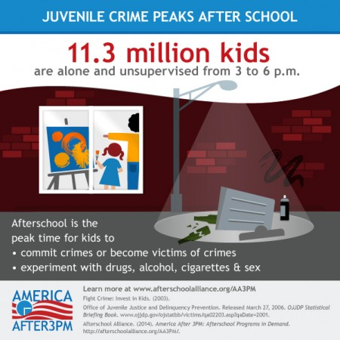  Sample Tweet 5  Law enforcement says #afterschool keeps kids safe; @GovRauner still springs  cuts on families.@InsertRepHandle #saveafterschool!  [Add this image to your Tweet!] | 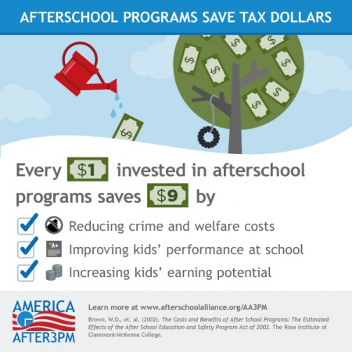  Sample Tweet 6  Nonessential? #TeenREACH keeps kids safe & supports working parents. @InsertRepHandle, save #communityschools #twill  [Add this image to your Tweet!]
Sample Tweet 7
Cuts to #afterschool increase delinquency & make kids less safe.
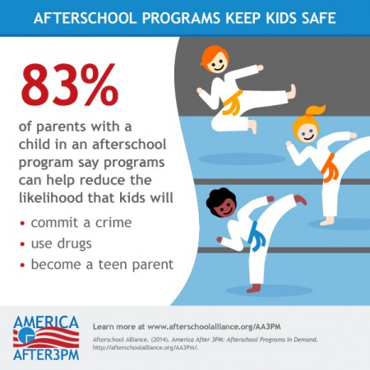
@InsertRepHandle, save #communityschools #twill
[Add the image below to your Tweet!]

